How FridgeChef Works
A beginner's guide to your app, your server, updates, security and costs
Written for Dhruv: someone learning programming by building a real project.
FridgeChef version 4.7.0 · updated 18 October 2026

How to read this guide
Sections 1–2 explain the big picture. Read them first, everything else builds on them.
Sections 3–7 answer your five questions: sharing the app, updating recipes, version numbers, security, and updates.
Sections 8–9 cover what you control and how to stop overbilling.
Section 10 is a cheat sheet of everyday commands; section 11 lists the next steps; section 12 explains everything new since version 4.0.0 (the new look, photos, testing on your phone).
Words in this style are file names or commands you can type.

1. The big picture
FridgeChef is not one program but four places that work together. Once you can picture these four boxes, every other question in this guide becomes much easier.
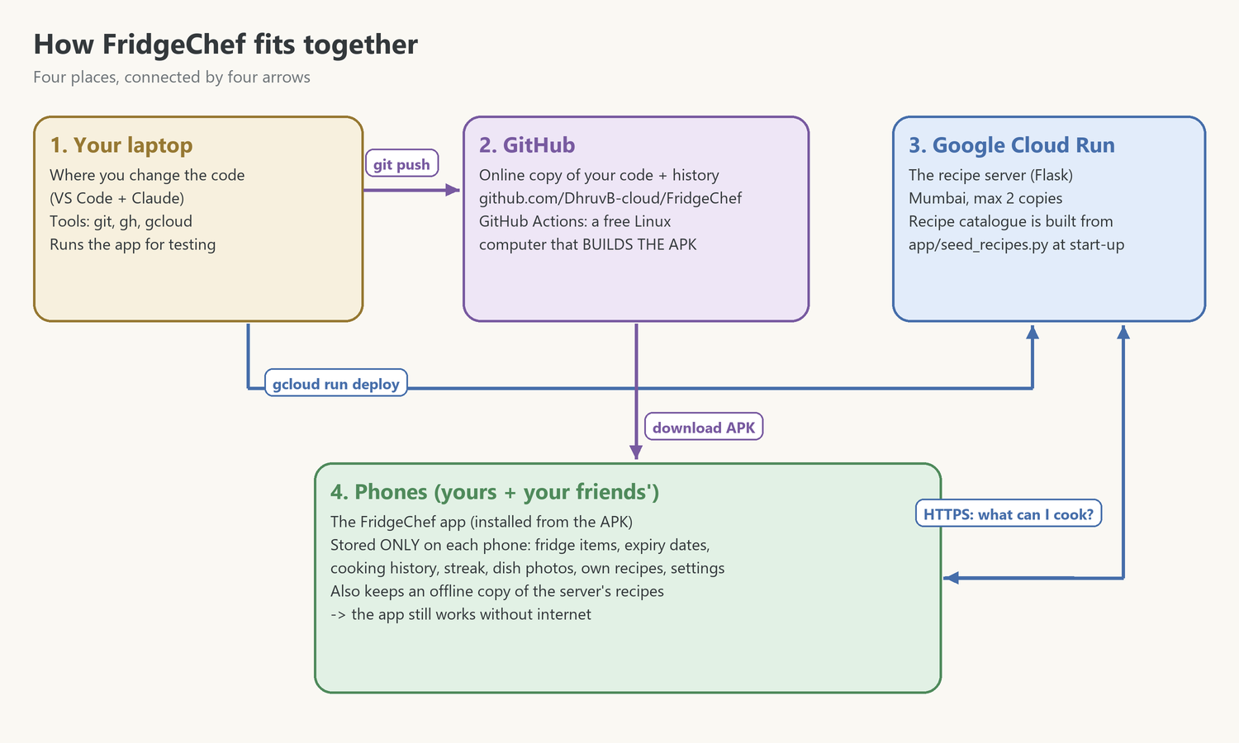
- Your laptop is the workshop. You change the code here and test it.
- GitHub is the online safe for your code. It also has free Linux computers (GitHub Actions) that turn the code into an APK file.
- Google Cloud Run is a computer in Google's Mumbai data centre that runs the recipe server. Phones ask it: "here is my fridge, what can I cook?"
- Phones run the app. Everything personal (fridge items, cooking history, photos) stays on the phone.

Words you will meet
Word | What it means (in plain words)
App / APK | The program on the phone. An APK is the installer file for Android apps (like a .exe on Windows).
Server | A program that runs on a computer somewhere and answers requests from other programs. Ours answers recipe questions.
API | The "menu" of questions a server understands, e.g. /api/recipes/search. The app and server talk only through it.
Cloud / Cloud Run | Renting someone else's computers. Cloud Run runs our server only while requests arrive, and costs nothing when idle.
Container / Dockerfile | A sealed box with Linux + Python + our server inside. The Dockerfile is the recipe for that box; Google builds it for us.
Repository (repo) | A project folder tracked by Git, with its whole history. Ours: github.com/DhruvB-cloud/FridgeChef
Commit / Push | Commit = save a snapshot with a message. Push = upload your snapshots to GitHub.
Deploy | Put a new version of the server online (gcloud run deploy).
Database (SQLite) | A file that stores data in tables. Each phone has one; the server builds its own from the code.
Build | Turning source code into something that runs, e.g. the APK. Done for us by GitHub Actions.

2. Where your data lives
This is the single most important table for understanding security, updates and privacy:
Data | Where it is stored | Who can see it
Fridge items, quantities, expiry dates | Each phone, in its own SQLite file | Only that phone's owner
Cooking history, streak, dish photos | Each phone | Only that phone's owner
Recipes a user creates | Each phone (never uploaded) | Only that phone's owner
Built-in recipe catalogue (21 recipes) | In the code (app/seed_recipes.py) → GitHub, the cloud server, and an offline copy on each phone | Everyone; it is meant to be public, like a cookbook
Server address | app/config.py | Everyone; it is only an address
Your Google and GitHub sign-ins | Your laptop only (Windows' secure credential store) | Only you

Key takeaway
No user data is stored in the cloud. When a phone asks for recipes, it sends its fridge list, the server answers, and the server forgets the list immediately. That keeps your friends' data private and makes the server much safer.

3. Sharing the app with friends (question 1)
Yes, you can send the APK to friends. GitHub builds it for you every time the app's code changes.

Where the APK comes from
Option | How | Best for
Actions artifact | GitHub → Actions tab → newest "Build Android APK" run → Artifacts → FridgeChef-apk (zip) | Testing it yourself. Needs a GitHub login; deleted after 30 days.
Release (recommended) | Create a version tag: git tag v4.0.0 then git push origin v4.0.0. GitHub builds the APK and attaches it to a Release page | Friends. A public link that never expires, e.g. github.com/DhruvB-cloud/FridgeChef/releases

What your friend does
- Open the Release link on their Android phone and tap the .apk file to download it.
- Android asks to allow installing unknown apps for the browser or Files app → allow it. (Apps from outside the Play Store are blocked by default.)
- Tap Install. Google Play Protect may warn "unknown developer" or offer to scan the app; choose Install anyway (or scan, then install).
- Open FridgeChef, allow notifications (for expiry reminders), and start adding fridge items.
Requirements: Android 7.0 or newer and a 64-bit phone (nearly every phone since about 2017). iPhones cannot install APKs; that would need a separate iOS build.
✅ Done (5 October 2026): the permanent signing key
Android checks a digital signature on every APK. An update is only accepted if it has the same signature as the installed app.
Every APK is now signed with ONE permanent key. GitHub keeps it encrypted in its Secrets, so friends can install every update over the old version and keep their data.
You have a backup of the key outside the project. Never run tools/make_signing_key.py again: a new key would make updates impossible for everyone.

4. Updating the recipes on the server (question 2)

How the server's "database" really works
The server does have a database file, but it is rebuilt from the code every time the server starts (Database._seed() reads app/seed_recipes.py). Cloud Run also wipes the server's disk whenever it starts a fresh copy. So you never edit the cloud database directly: you edit the code and redeploy.
This has a big advantage for a beginner: the recipe list is in Git, so every change is saved in history, can be reviewed, and can be undone.

Step by step: add a new recipe (example: Lemon Rice)
- Open app/seed_recipes.py. Copy an existing Recipe(...) block (for example Jeera Rice) and paste it above the line ] that closes SEED_RECIPES. Change the values:
Recipe(
name="Lemon Rice", cuisine="Indian", is_veg=True, prep_minutes=20, servings=2, # basic facts
meal_types=["Lunch", "Dinner"], nutrition_tags=["Balanced"], # when + tags
appliances=["Stove", "Rice Cooker"], # ANY one is enough
ingredients=[I("rice", 200, "g"), I("lemon", 1, "pcs"), # name, amount, unit
I("peanuts", 30, "g", True), I("turmeric", 0.5, "tsp")], # True = optional
steps=["Cook the rice and let it cool.", # one string per step
"Temper peanuts and turmeric in oil, mix with rice and lemon juice."]),

- Scroll down to the NUTRITION table and add a line with protein, carbs and calories per serving: "Lemon Rice": (5, 48, 280),
- Give it a photo: find a freely licensed photo of the dish on Wikimedia Commons, add the recipe and the photo's file name to tools/recipe_photos.json, then run .\.venv\Scripts\python tools\fetch_recipe_photos.py fetch. It downloads the photo, crops it square and records the photographer's credit (see section 12).
- Test on your laptop: .\.venv\Scripts\python -m unittest discover tests, then run the app and look for the recipe.
- Save to GitHub: git add --all, git commit -m "Add Lemon Rice recipe", git push.
- Deploy the server: run the deploy command from docs/CLOUD_DEPLOYMENT.md (section 4). It takes about 4 minutes.
- Done. Every phone receives Lemon Rice the next time its Recipes tab loads, saves it for offline use, and downloads its picture from the server. No new APK is needed.

Changing or removing a recipe
- Change: edit its block, test, commit, push, deploy. Phones update their saved copy on the next Recipes visit.
- Remove: delete its block and deploy. The server stops offering it, but phones keep the copy they already saved (the app never deletes recipes on its own).
Later, if you want
If you ever want to edit recipes without touching code (for example from a web page), the next step is a managed cloud database such as Firestore plus a small password-protected admin page. That's a good learning project for later; for 21 recipes, code is simpler and safer.

5. Version numbers (question 3)
Versions are written MAJOR.MINOR.PATCH, e.g. 4.1.2. This is called semantic versioning:
- PATCH (4.0.0 → 4.0.1): a bug fix, nothing new to learn for users.
- MINOR (4.0.1 → 4.1.0): a new feature that doesn't break anything.
- MAJOR (4.1.0 → 5.0.0): big changes, e.g. a redesign or a new data format.

The version numbers in this project
Where | What it does | When to change it
APP_VERSION in app/__init__.py | Shown at the bottom of the Profile tab | Every app release
version in buildozer.spec | Android compares it to decide whether a new APK is an update | Every app release; it must go up, or Android refuses the update
Git tag, e.g. v4.1.0 | Marks the exact code of a release and triggers the public Release page | When you publish an APK to friends
Cloud Run revision, e.g. fridgechef-api-00002-xyz | Each deploy creates a new revision; Google keeps the old ones | Automatic, nothing to do
API_VERSION in app/api_schema.py | Version of the language app and server speak (JSON format) | Only if you change that format in a way old apps wouldn't understand

Release checklist (example: 4.1.0)
# 1. change APP_VERSION in app/__init__.py and version in buildozer.spec to 4.1.0
.\.venv\Scripts\python -m unittest discover tests # 2. all tests must pass
git add --all # 3. stage the changes
git commit -m "Release 4.1.0: <what is new>" # 4. save a snapshot
git push # 5. upload the commits
git tag v4.1.0 # 6. label this exact snapshot
git push origin v4.1.0 # 7. upload the label (GitHub builds the APK)

6. Security: is it safe if the code is public? (question 4)
Think of a restaurant: the menu is public (that's the code on GitHub), but the kitchen keys are not (your Google and GitHub sign-ins). Publishing the menu doesn't let anyone into the kitchen.

What is (and isn't) in the public code
- In the code: the app, the server, the recipes, the server's address. All harmless to share.
- Not in the code: passwords, API keys, your Google login, your GitHub token, any user data. We checked for these before the first upload, and .gitignore keeps local data files out.

What an attacker could try, and what stops them
Attempt | What happens
Read the recipes | Allowed; they are public on purpose.
Change or delete data on the server | Impossible: the API has no endpoints that write data, and the server is rebuilt from your code on every start.
Send broken or weird data | The server checks every request and answers "400 Bad request".
"SQL injection" (sneaking database commands into input) | All database queries use ? placeholders, so input is always treated as plain data, never as commands.
Steal your users' data | There is none in the cloud; it stays on each phone (section 2).
Listen in on the connection | All traffic uses HTTPS (encrypted), and the app verifies the server's certificate.
Take over your Google Cloud / GitHub | Only with your passwords. Turn on 2-step verification on both accounts.
Flood the server with millions of requests | The real risk: it can't break anything, but it can cost money. See section 9.

Your security habits
- Turn on 2-step verification for Google and GitHub (5 minutes each).
- Never paste a password, key or token into a code file. If one is ever needed, use GitHub Secrets or Google Secret Manager.
- If you ever accidentally commit a secret: change the secret immediately. Deleting it from the code is not enough, because Git history keeps it.

7. Will my friends get updates automatically? (question 5)
It depends on which part you change. The server updates for everyone instantly; the app on each phone only changes when a new APK is installed.
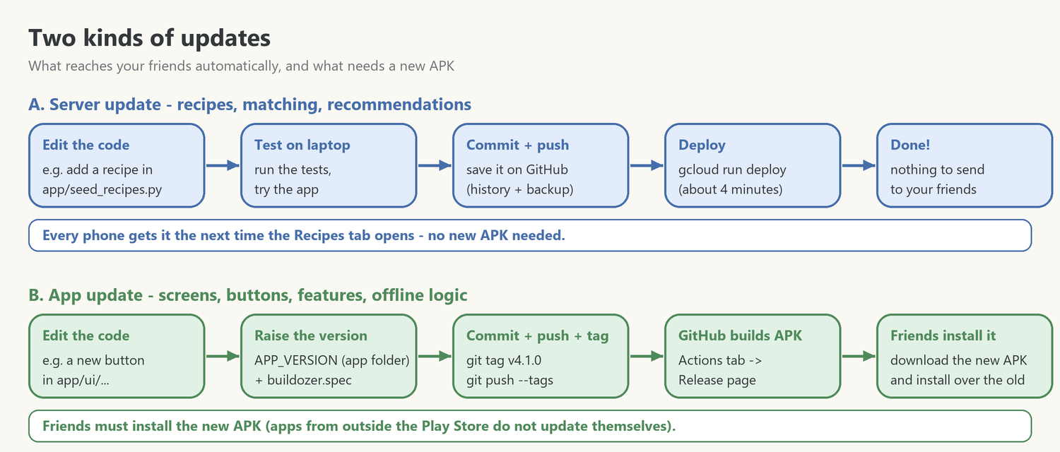
What you change | Deploy server? | New APK?
Add / edit / remove a recipe | Yes | No (optional: newer offline pictures)
Matching, sorting or recommendation rules (app/recipe_engine.py) | Yes | Only for the offline mode, which uses the copy inside the app
Screens, colours, buttons, new features (app/ui/...) | No | Yes
App name, icon, Android permissions (buildozer.spec) | No | Yes
Server settings (region, memory, max copies) | Yes | No
Server address (app/config.py) | No | Yes

How friends get a new APK today: you publish a new Release and send them the link. They install it over the old version, and their data stays, provided the signing key is the same (section 3).
Two ways to make this easier later:
- An "Update available" banner in the app: the server tells the app the newest version, and the app shows a button that opens the Release page.
- Publish on the Google Play Store (one-time $25 developer fee). Play installs updates automatically, but each release goes through a review.

8. What you control
Area | Where | Examples
Recipe catalogue | app/seed_recipes.py, assets/recipe_images/ | Names, ingredients, amounts, steps, cuisine, veg/non-veg, meal times, nutrition, pictures
Matching & recommendations | app/recipe_engine.py, app/meal_time.py | What counts as "ready to cook", ranking order, meal-time windows
Ingredient suggestions & food types | app/ingredient_catalog.py | The type-ahead list; which words count as non-veg or egg
Look and feel | app/ui/widgets.py and the screen files | Colours, roundness, layouts, texts
App identity | buildozer.spec, assets/app_icon.png | Name, icon, version, permissions
Server location & size | Deploy command (docs/CLOUD_DEPLOYMENT.md) | Region, memory, CPU, max copies (cost limit)
Spending | Google Cloud console → Billing | Budget alerts, kill switch, turning billing off
Who sees the code | GitHub → Settings | Public or private repository

What you can NOT see (by design)
Your friends' fridge items, history and photos never leave their phones, so you can't see them, and neither can anyone else. Google's server logs only show that a request arrived (time, size, rough location), not its contents.

9. Costs: how to stop overbilling (question 6)

How billing works
Google charges only for usage above the free tier, which resets every month. Free each month: 2 million requests, 180,000 vCPU-seconds and 360,000 GiB-seconds of computing, plus 1 GB of data sent out (North America). FridgeChef uses a tiny fraction: a request takes about 0.1 seconds and returns about 40 KB.
Expected bill for you and your friends: ₹0.

The protection layers you have
Layer | What it does | Status
Free tier | Normal use costs nothing | ✅ automatic
Scale to zero (--min-instances 0) | No requests → no running server → no cost | ✅ set
Max 2 copies (--max-instances 2) | Limits how much computing can run at once, even under heavy traffic | ✅ set
₹50 budget alert | Emails you at ₹25, ₹45 and ₹50 (and if ₹50 is forecast). It does not stop anything, and the emails can arrive hours late | ✅ set
Automatic kill switch | When the budget is exceeded, a tiny cloud function switches off billing for the project, which stops everything | ✅ set and tested (5 Oct 2026)
Manual stop | Commands below: you can stop everything in under a minute | ✅ always available

The honest worst case
Normal use costs nothing. But if someone deliberately flooded the server non-stop for a whole month, the 2 capped copies could cost very roughly ₹8,000–11,000 in computing, plus data-transfer charges (around $0.12 per GB), which have no built-in cap.
That's unlikely for a small hobby app, but it's exactly why the kill switch is worth 15 minutes of setup: it turns a possible surprise bill into, at worst, the server going offline for a while (the app keeps working offline).

How to stop spending immediately
Run these in PowerShell on your laptop. Each one is stronger than the one before:
# 1. Make the server smaller: at most ONE copy (halves the worst case)
gcloud run services update fridgechef-api --region asia-south1 --max-instances 1

# 2. Delete the server (phones switch to offline mode; you can deploy it again any time)
gcloud run services delete fridgechef-api --region asia-south1

# 3. Switch billing OFF for the project (stops EVERYTHING in it that costs money)
gcloud billing projects unlink fridgechef-56971

# 4. Check what you have spent: open this page in your browser
# https://console.cloud.google.com/billing -> Reports

Without the command line: Google Cloud console → Billing → Account management → find project fridgechef-56971 → ⋮ → Disable billing.

The kill switch, in plain words
- Your ₹50 budget publishes a small message to a Pub/Sub topic (Google's mailbox for programs) whenever spending is checked.
- A tiny cloud function reads each message. If actual spending is over the budget, it calls the Billing API: "unlink billing from fridgechef-56971".
- Without billing, Google stops the project's paid services. To turn things back on, you re-link billing (one command) after checking what happened.

10. Everyday cheat sheet
Open PowerShell (or the VS Code terminal) and start with cd F:\Projects\FridgeChef.

Run and test
.\.venv\Scripts\python main.py # start the app on your laptop
.\.venv\Scripts\python -m unittest discover tests # run all automatic tests

Save your work to GitHub
git status # what changed since the last commit?
git add --all # stage everything for the next snapshot
git commit -m "Describe what you changed" # save the snapshot with a message
git push # upload it to GitHub
git log --oneline -5 # the last 5 snapshots

The APK
gh run list --workflow build-apk.yml --limit 3 # the latest APK builds and whether they worked
gh run watch # follow a running build live
git tag v4.1.0 # label a release...
git push origin v4.1.0 # ...and publish it (builds the APK + Release page)

The server
# is the server alive? (should answer status: ok)
Invoke-RestMethod https://fridgechef-api-847387196162.asia-south1.run.app/api/health
# the last 50 lines of the server's log (errors, requests)
gcloud run services logs read fridgechef-api --region asia-south1 --limit 50
# every version (revision) you have deployed
gcloud run revisions list --service fridgechef-api --region asia-south1

The full deploy command (with a comment on every line) is in docs/CLOUD_DEPLOYMENT.md, section 4.

11. Recommended next steps
# | Step | Why | Priority
1 | Permanent APK signing key (stored in GitHub Secrets) | Friends can install updates without losing their data | ✅ Done
2 | Billing kill switch | Caps the worst-case bill automatically | ✅ Done
3 | 2-step verification on Google and GitHub | Protects the accounts that control everything | ✅ Done
4 | First Release: git tag v4.7.0 | A public download link for friends | After the phone test of 4.7.0
5 | "Update available" banner in the app | Friends notice new versions | Nice to have
6 | Automatic server deploy from GitHub | Pushing recipe changes also updates the server | Nice to have
7 | Google Play Store | Automatic updates, easier installs | Later

Every one of these is a good learning project. Do them one at a time, and ask Claude to explain each line as you go.

12. What's new since version 4.0.0
Everything below was built between 6 and 18 October 2026 on the Git branch fix/4.0.1 (a branch is a separate line of work: main stays unchanged until we merge, i.e. combine, the two). It reaches phones with the next APK build.
Version | What changed (in plain words)
4.0.1 | Bugs from your phone test: the keyboard opens on a normal tap; the Recipes page no longer gets stuck when a swipe starts on the Recommended strip; Share shows the recipe card first and reports the real error; faster screens (pictures load in the background, small thumbnails); the tab you touch lights up instantly.
4.1.0 | The Fridge tab is drawn as a real fridge (from your sketch). Items are containers with the name on the label. Water is built in (never expires, unlimited). Expired food turns mouldy green and can only be thrown away - with a disappearing animation. Tapping fresh food: change the quantity or remove it. Two items with the same name stay separate; cooking uses the one expiring soonest.
4.2.0 | One kitchen look for all tabs: Fridge = a fridge, Recipes = an oak-wood counter with thumbnails, Cookbook = a leather book whose cover opens, Calendar = a paper wall calendar, Profile = a chef's corner.
4.3.0 | A stylish layer on top: the Poppins font, a colourful background, glossy gradient buttons with a glow, a dark floating tab bar, glowing header badges, photo-style recipe cards.
4.4.0 | Glass fridge shelves (see-through top, frosted edge, shadow) and a clear acrylic bin in the door.
4.5.0 | 12 kinds of containers and the option to use your own container pictures.
4.6.x | 3D pictures (replaced again in 4.7.0) and a fix for a thin line after the Cookbook cover opened.
4.7.0 | 2D pictures everywhere (Google Noto Emoji); real food photos for all 21 recipes, each with its photographer's credit; Change photo / Use original for every recipe.

Where each container stands in the fridge
- Shelves: glass jar, tub, can, basket, greens.
- Leftovers shelf: dish, food box, cooking pot, takeout box.
- Door rack: bottle, carton, glass - and the built-in Water.
Pick the container with the little picture next to the Name box in Add item (a jar unless you choose another).

Using your own pictures
- A recipe photo, on your phone: open the recipe → Change photo → choose a picture. Use original brings the built-in photo back. Your photo stays on your phone only.
- A fridge container, for everyone: save a PNG with a see-through background as assets/icons/custom/<name>.png (for example jar.png), then run .\.venv\Scripts\python tools\make_assets.py containers. The instructions are in assets/icons/custom/README.txt.
- A built-in recipe photo, for everyone: change the file name in tools/recipe_photos.json and run tools\fetch_recipe_photos.py fetch (only Wikimedia Commons photos with a free licence).

Pictures, font and their licences
A licence is the owner's permission to use their work, with conditions. Everything in the app has one:
What | Licence | Where the text is
Poppins font | SIL Open Font License (free, keep the licence with the app) | assets/fonts/OFL.txt
Pictures (containers, icons, app icon) | Google Noto Emoji, Apache 2.0 | assets/icons/NOTO_LICENSE.txt
Recipe photos | CC0, public domain, CC BY or CC BY-SA (Wikimedia Commons) | assets/recipe_images/credits.json; shown on each recipe page

Why the photo credits matter
Free photo licences are a deal: you may use the photo, and in return you name the photographer. The app does this under every recipe photo (tap it for the full details). Never copy photos from random websites - they belong to whoever took them, and your code is public.

Testing on your own phone (Android Studio's adb)
Android Studio cannot build FridgeChef (it is a Python app, built by GitHub Actions), but it installed adb (Android Debug Bridge), a program that talks to your phone over a USB cable. Your phone: Samsung Galaxy A52s, Android 14.
- Once: Settings → About phone → Software information → tap Build number 7 times, then turn on USB debugging in Developer options and tap Allow when the phone asks.
$adb = 'F:\Tools\Android\Sdk\platform-tools\adb.exe' # where Android Studio put adb
& $adb devices # is the phone connected?
gh workflow run build-apk.yml --ref fix/4.0.1 # build an APK from the weekend branch (~15 min)
gh run download --name FridgeChef-apk --dir F:\Temp\apk # download it (to F:, never C:)
& $adb install -r F:\Temp\apk\<the .apk file> # install over the old app; data stays
& $adb logcat -s python # watch the app's messages and errors

Your storage rule
Your C: drive is short on space, so everything lives on F: - projects in F:\Projects, tools in F:\Tools, downloads and caches in F:\DevCache, temporary files in F:\Temp. Claude and every helper agent follow this rule automatically and ask before anything would go to C:.

Next time
- Test 4.7.0 on your phone: keyboard, sharing, the new fridge, photos, Change photo.
- Merge fix/4.0.1 into main → GitHub builds the signed APK automatically.
- First public release for your friends: git tag v4.7.0 and git push origin v4.7.0.
- Optional: deploy the server again so it also has the new recipe photos.

